Ground Foundry
Data Infrastructure for the Era of Experience

The Insight
Major frontier labs have built the internal data flywheel on their own users. ChatGPT conversations, Claude interactions, Gemini queries. Powerful signals, but ones that primarily reflect the users they already have.
Consumer chat doesn't capture how a scientist thinks through a novel experiment, or how a senior engineer navigates a legacy Cobol codebase. These are the out-of-distribution signals that drive capability gains at the frontier, and internal data flywheels can't fully produce them.
The existing answer is human annotation: experts paid to perform designed tasks in controlled settings. It is the classroom of AI training. What frontier models also need is the equivalent of on-the-job learning, where the tasks, constraints, and failure modes are all real.
The problem compounds with scale. Major labs consistently look for out-of-distribution data for improving the models. Labs outside the big ones have weaker flywheels and less signal diversity.
The company building the data infrastructure to capture, refine, and deliver that external signal at scale, will become the company every lab depends on.

The Market
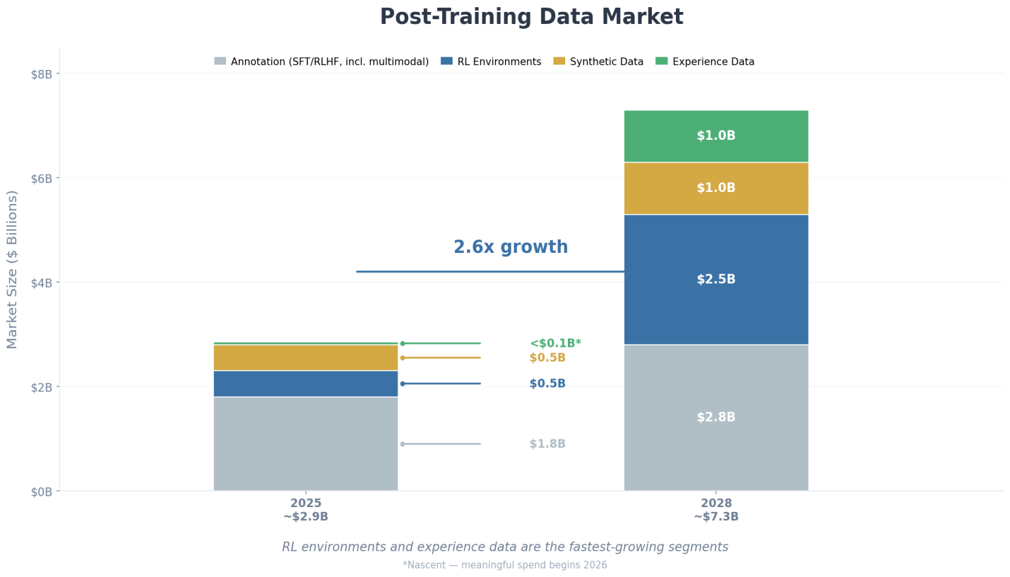
We estimate the post-training data ecosystem at ~$3B in 2025, reaching ~$7B by 2028. RL environments and experience data are the fastest-growing segments as the binding constraint shifts from annotation volume toward signal quality, authenticity, and verifiability. The key bottleneck is no longer annotation capacity, but the real-world fidelity of the data used to shape model behavior after pretraining.
The incumbents, Surge AI ($25-30B valuation) and Scale AI ($29B valuation), built their businesses on transactional annotation and are now racing to add RL environments on top. Pure RL environment builders (Mechanize, Fleet) sell simulated sandboxes but often lack authentic human behavioral traces.
The missing piece is neutral infrastructure for capturing and refining long, real-world trajectories from external workflows at scale. We're building it.

The Thesis
As AI models get cheaper and more capable, value shifts to three forms of human signal:
Intent: The gap between what humans ask for and what they actually want. Only revealed in authentic, real-world interactions.
Outcome: Verification that it actually worked. AI without verification is noise at scale. Every failure becomes a training sample.
Taste: Subjective human judgment when multiple outputs are correct but humans still prefer one. It shifts over time, and fresh signals are perpetually required.
We’re calling this experience data: Authentic traces of humans and AI working together in the real-world. It is difficult to scrape, crowd-source, or synthetically generate. It is the critical supplement every frontier lab needs but cannot produce from internal data alone.

The Experience Data Flywheel
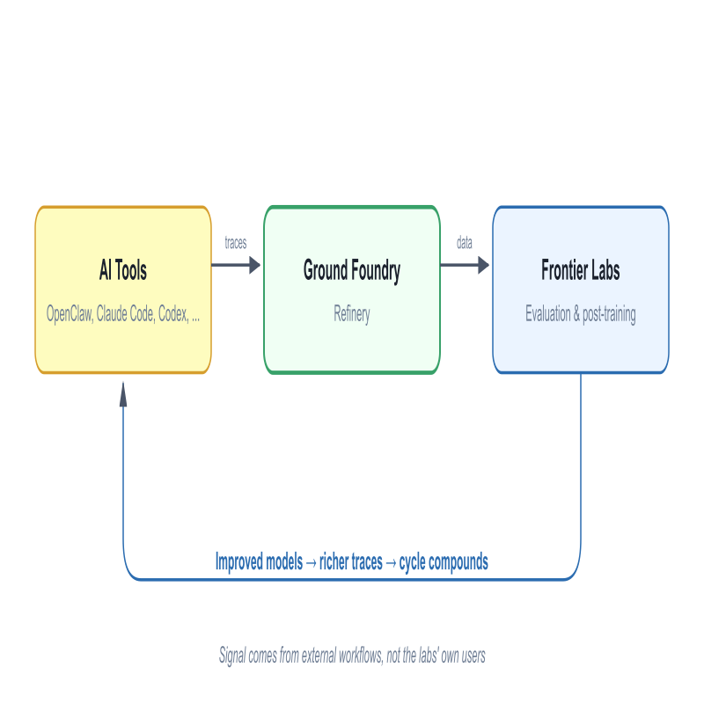
Ground Foundry is building what every frontier lab has internally, but doesn’t yet exist for the broader ecosystem.
Researchers and developers use AI tools for real work: OpenClaw, Claude Code, Codex, and others across coding, scientific research, and beyond. Their interaction traces flow through our refinery to frontier labs, who use them for model evaluation and post-training. The improved models ship back into the same tools, producing richer interactions and higher-quality traces. Each cycle compounds. The critical difference: the signal comes from external workflows, not the labs’ own users. It is not feasible to plug non-lab product data directly into lab evaluation and training pipelines. That is the infrastructure gap we fill.
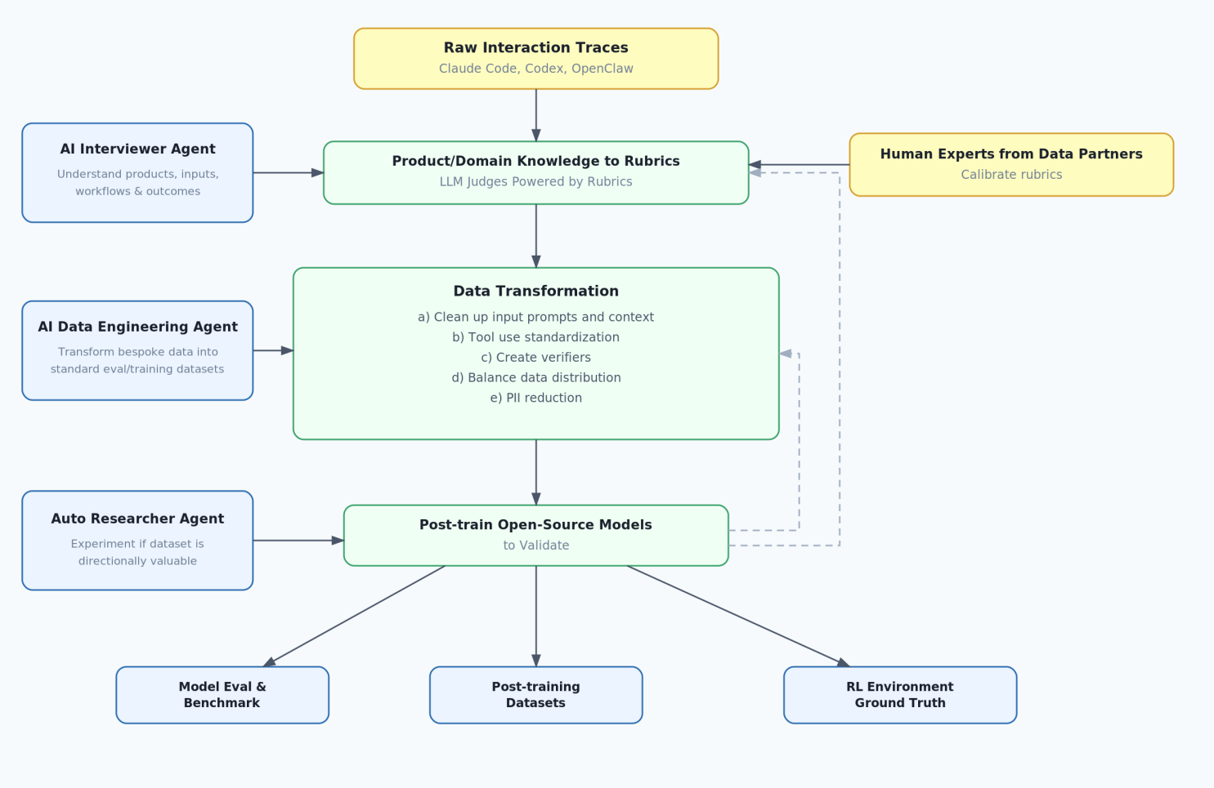
The refinery turns raw traces into deliverable outputs through four stages:
Collection: Session logs from Claude Code, Codex, OpenClaw, and other AI agents, parsed into structured traces with automatic PII redaction.
Refinement: Our AI interviewer agent extracts domain knowledge from data partners and converts it into scoring rubrics. Human experts calibrate; LLM judges apply at scale. Our data engineering agent cleans prompts, standardizes tool use, and balances distribution.
Validation: Our automated researcher agent trains open-source models on the output to verify the data moves performance. Results feed back, sharpening the pipeline each cycle.
Delivery: Three outputs from one system - model evaluations & benchmarks, curated post-training datasets, and RL environment ground truth with authentic reward signals.
These outputs reinforce each other. Better data improves lab models, which validates our quality, drives benchmark adoption, attracts more researchers, and unlocks more supply.

Early Momentum
Pre-revenue. Both sides of the market are warming up. Fundraise accelerates the timeline.
Demand: Lab Interest
- xAI: UI coding trajectories. $100K Pilot completed.
- Nvidia: COBOL code repositories. In talks.
- Qwen: Scientific Trajectories. In talks.
"If you can offer high quality out-of-distribution data on rare or niche coding languages, we'll buy them immediately." - Data PM, Nvidia
"We consistently need long-horizon agent tasks to A/B test our models, this is by far the most effective way to measure improvements" - Data Ops, ByteDance Seed
Supply: Data Partnerships
Active conversations with small and medium AI-native apps and platforms (highest data readiness), digital-native SaaS platforms with structured data that needs instrumentation, and international vendors. The trace licensing model aligns incentives and reduces friction: partners retain ownership, we handle the data infrastructure and lab supply.

Founding Team
Kai Du, CEO: Former Head of GenAI at Turing. Led the pivot from remote hiring to LLM post-training data. He built the operational playbook for sourcing, refining, and delivering data to frontier labs at a $200M annual revenue scale. Owns supply and product. Previously ML lead at Meta, Zoox, Coupang.
Alex Cheung, COO: Former GM APAC at Turing. Built the unit from zero to one. Closed $20M+ in AI lab deals with Character.ai, Augment Code, Kimi, Qwen, ByteDance Seed, and Tencent. Owns supply and demand.
Char Kwon, Advisor: Founding PM at Turing. Scaled the company from $0 to $2.2B valuation.
Together they built Turing's data business end to end. The lab relationships, the knowledge of what data actually moves model performance, and the network of researchers who trust them are the unique advantages they carry forward.

Where We Focus
We pick verticals by AI adoption rate and data accessibility.
Coding: The Revenue Engine
AI coding tools are widely adopted and generate massive trace volume. Engineer interactions with Claude Code, Codex, and Cline produce long trajectories verified by test suites and CI/CD outcomes. This is one of the cleanest outcome signals available, and where labs are actively buying today. Coding is our fastest path to revenue and the proving ground for the refinery pipeline.
AI for Science: The Wedge into Enterprise R&D
AI adoption in research is growing rapidly, but data access is underserved. Researchers use Claude Code, Codex, and OpenClaw daily on real scientific work, and outcomes are verifiable: code runs or it doesn't, experiments replicate or they don't, results are mathematically provable or they aren't. This is among the cleanest reward signals for RL, and scientific trajectories sit at the frontier of model capability.
We provide AI agents to researchers and subsidize their tool access. In return, they share interaction traces and flag complex cases, which we plan to open-source as OpenClaw benchmarks.
Expansion Verticals
- Computer use and visual reasoning: Human and AI-powered task traces in browser and desktop environments, verified by task success.
- Enterprise workflows: Productivity tools and common business processes: screen recordings, task completions, and process traces verified by workflow outcomes.
The infrastructure is shared across all verticals: ingestion, LLM judge, quality pipeline, compliance, benchmark packaging. Each new domain expands the supply network. None require a new product build.

What We Offer
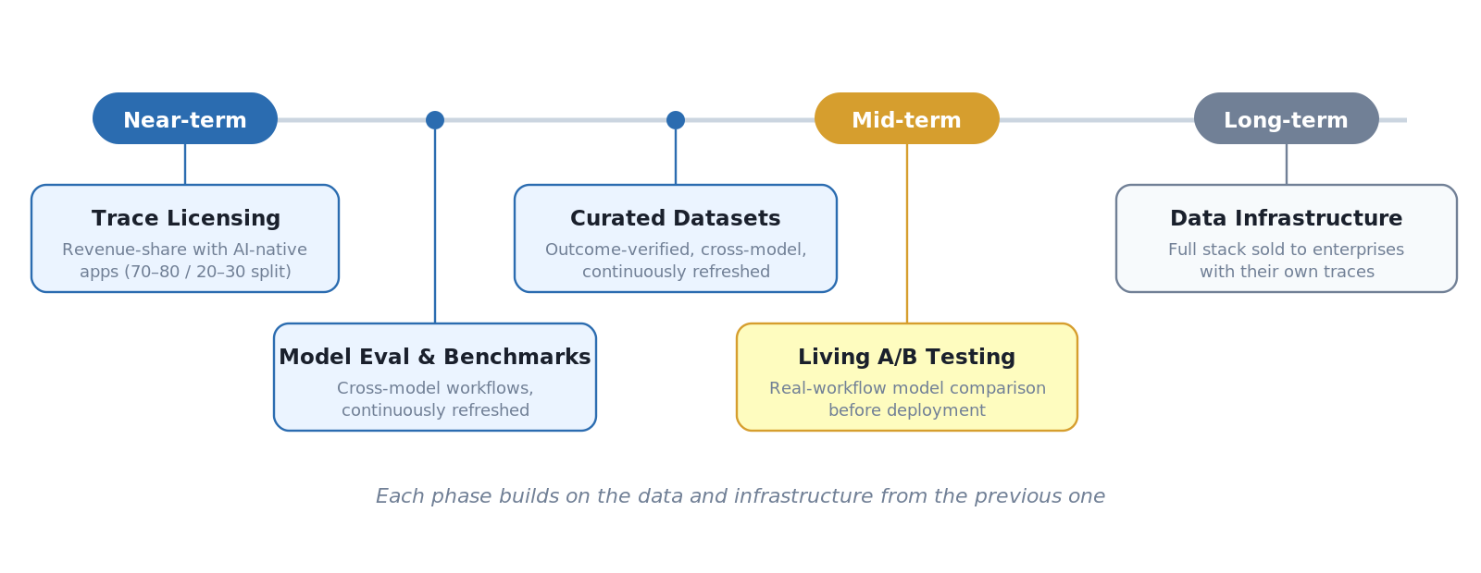
Trace licensing partnerships (near-term): Revenue-share partnerships with coding agent companies and AI-native apps. Their users generate coding interactions continuously; we refine and deliver them to frontier labs. Partners retain 70–80% of revenue; we keep 20–30%.
Model evaluation & benchmarks (near-term): Benchmarks built from real cross-model workflows that are out-of-distribution relative to what labs have internally. Per-benchmark licensing, refreshed continuously.
Curated post-training datasets (near-term): Targeted datasets refined through our data refinery. Outcome-verified, cross-model, and continuously refreshed.
Living A/B testing (mid-term): Data partners route partial traffic through our eval surface to compare model versions on real workflows before deployment. Once a lab depends on our evaluation to decide whether to ship a model update, switching costs compound, the same dynamic that made Facebook’s A/B testing infrastructure indispensable internally.
Data infrastructure for data partners (long-term): Full ingestion, LLM judge, quality scoring, and outcome verification stack, sold to enterprises that have their own operational traces but no efficient way to process and refine them.

Why This is Infrastructure, Not Services
Imagine two companies, both starting from the same place.
The first builds deep supply relationships, defensible vertical coverage, eval credibility. A real business with a $50–$200M ARR ceiling. But it competes on execution and is always one better-funded competitor away from margin compression.
The second captures intent, outcome, and taste across every surface where humans interact with AI under real stakes. It expands beyond labs. It becomes where the signal lives: not a supplier, but a standard. The ceiling is different.
Same starting point. Different first moves. We are building the second. In the early stages, we look like the first. That is not a contradiction, but a sequencing problem. TSMC looked like a contract manufacturer before it became irreplaceable.
Four structural assets a well-capitalized copycat would struggle to reproduce in 18 months:
- Model evaluation as infrastructure: Labs are unlikely to deprecate benchmarks they have published against. If you define the benchmark, you define what good data means.
- Cross-model comparative data: Tool-agnostic by design. We see how every major model performs on the same real tasks. No individual lab easily possesses this view.
- The data refinery pipeline: Improves with every trace processed. Competitors who start later face a compounding technology disadvantage that widens over time.
- Consent and trust infrastructure: SaaS companies sitting on similar traces cannot sell them. We are built from day one with data as the product, consent-verified provenance, auditable lineage, and per-buyer exclusivity enforced through isolated licensing agreements. Harder to build than the refinery itself.
We believe this is a winner-take-most market. Supply-side lock-in from researchers. Demand-side network effects from labs. And benchmark lock-in that compounds both. Once labs publish results against a standard, switching is costly. Competitors in adjacent categories — RL environment builders, annotation vendors — depend on the same raw signal we capture. They are not just peers; they are potential customers.

GTM Engine: Researcher Trust
Trust with researchers is the foundation, not a marketing channel, but the mechanism that generates supply, validates quality, and compounds over time.
- Data quality as distribution: Quality drives researcher referrals, which drives organic pipeline growth. Trust is the distribution channel, not a marketing line item.
- Demand forecasting: Researcher conversations are proprietary intelligence, a rolling signal of where model capability is breaking down, fed directly into our supply roadmap before competitors see it.
- OpenClaw benchmarks as a hiring pipeline: We build coding and scientific workflow task benchmarks that the researchers and engineers we want already use daily. Contributors to these open-source benchmarks become our talent pipeline.
- Landing lab buyers: First deals come through existing relationships. Pilot-first: deliver a sample dataset, let the lab's training team evaluate quality against their internal benchmarks, then convert to recurring.
- Landing data partners: We approach data-rich companies as a monetization partner, not a buyer. They retain ownership. We handle infrastructure and lab relationships. Low friction, aligned incentives.

The Raise: $5M SEED
The market for post-training data is being restructured now. Building on cash flow over three years risks arriving after the key positions are taken. $5M buys 18 to 24 months to build the infrastructure that turns each engagement into a compounding asset, not just a delivered project.
- The refinery (60%: AI Infrastructure + R&D): DataClaw integration, LLM judge pipeline, automated quality scoring, eval tooling, OpenClaw benchmarks, and trust systems. Every dataset trains the system. Costs drop with volume; competitors stay labor-bound. If we define the benchmark, we define what good data means.
- Data supply (25%: Data & Researchers): Researcher program, data partnerships, tool subsidies. Benchmarks attract researchers, researchers generate traces, traces fund better benchmarks. This is the supply engine for the flywheel.
- Operations (15%: G&A): Legal, compliance, operational infrastructure.
Structured as SAFEs.
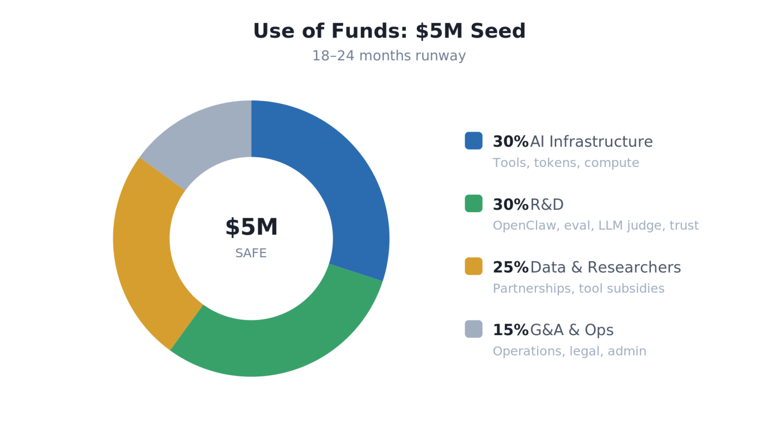

Long-Term Vision

In 3 to 5 years, most knowledge work will be performed by AI agents. Agent-generated data becomes abundant and commodity. The scarce input is authentic human judgment, scattered across thousands of products and platforms that lack the infrastructure to refine or trade it. Ground Foundry is that infrastructure: a neutral layer that aggregates and refines human signals from across the ecosystem, serving AI labs that need external signal and products that sit on signal they cannot use alone.

"Welcome to the Era of Experience." - David Silver & Richard Sutton

APPENDICES

APPENDIX A: Competitive Landscape
Every player solves part of the problem. No one combines all of it.
Category | Examples | What they do | What they lack
Annotation and expert data | Scale AI, Surge AI, Micro1, AfterQuery | Human-generated training data, from volume labeling to specialized expert datasets | Authentic workflow traces; cross-model visibility; data is manufactured, not captured
RL environment builders | Mechanize, Fleet, Applied Compute | Simulated sandboxes for training AI agents via reinforcement learning | Real human behavioral traces from external workflows
RL fine-tuning tools | Augento, TrainLoop | Help teams fine-tune models with reinforcement learning | No supply network; no benchmark or eval layer
Lab programs | OpenAI, Anthropic researcher grants | Fund researchers for internal data collection | Collect nothing structured back; no cross-model data
The gap is structural. Every category above either manufactures data in controlled settings or processes data someone else collected. Nobody captures authentic traces from real external workflows, refines them through a quality infrastructure, and delivers them across labs. Nobody combines tool subsidies, ambient cross-model collection, open-source benchmarks, and commercial delivery in a single flywheel.

APPENDIX B: Infrastructure
OpenClaw is our open-source agent framework and benchmark infrastructure. Converts real research traces into evaluation suites with cross-model comparative data no single lab possesses. Contamination creates constant demand for refresh, driving recurring revenue.
DataClaw parses session logs from Claude Code, Codex, and OpenClaw into a unified structured format. PII redaction and secret removal handled automatically. The ingestion substrate for the entire infrastructure.
LLM Judge Pipeline scores difficulty, classifies by domain and signal type, and escalates edge cases to human expert review. Core IP that improves with every trace processed.
Data Supply Tiers
- Tier 0: Digital records. Exportable structured data. Baseline filter. Low moat.
- Tier 1: Domain-specific repos. Code in rare languages and specialized domains. Verification is cleanest here. Medium moat.
- Tier 2: Proprietary workflows. Enterprise workflow traces with intent and outcome signal. High moat.
- Tier 3: Non-digital knowledge. Manuals, SOPs, institutional knowledge no synthetic source can replicate. Highest moat.
The real competitive advantage lives at Tiers 2–3. Our infrastructure is designed to reach them through embedded capture in authentic workflows.
Sample Data
A sample experience data point (coding trajectories with full intent-to-outcome traces) is available at: https://drive.google.com/drive/folders/1KGd776BNle2DcDCSFiYC-fhs9Lo_xRvI?usp=drive_link

APPENDIX C: Data Paradigms and Signal Degradation
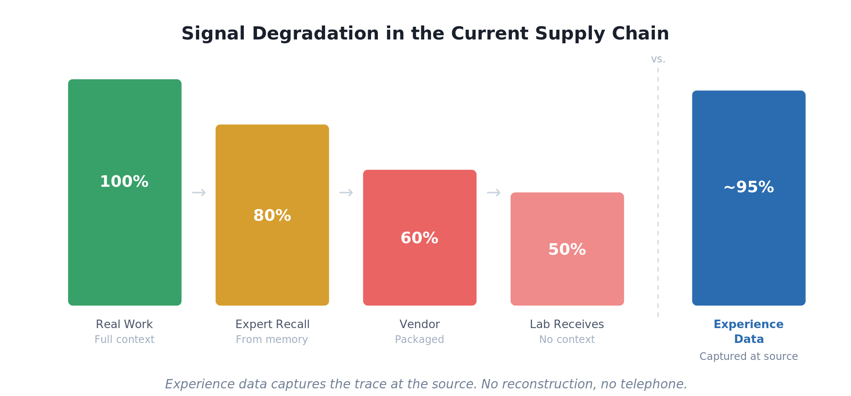
The current data supply chain degrades signal at every handoff: real work carries full context (100%), but by the time an expert recalls it, a vendor packages it, and a lab evaluates it, roughly half the signal is lost. Experience data bypasses this chain by capturing traces at the source, in authentic workflows, with full intent and outcome intact.
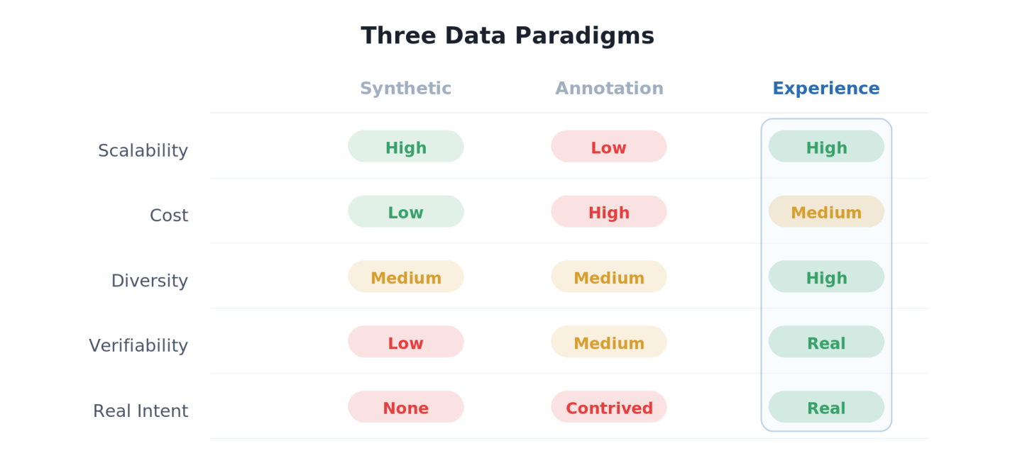
Three paradigms supply post-training data. Synthetic data scales cheaply but contains no authentic human signal. Human annotation provides expert quality but is costly, slow, and contrived. Experience data, captured from real workflows, combines high diversity, real verifiability, and authentic intent at scale.

